ART EXHIBITION
At St. Andrew’s church Wickhampton, in Broadland
OPEN: Saturday 1st July until Saturday 8th July
10.30am – 5.30pm
“CELEBRATING THE BEAUTY OF NATURE AND ARTS”
Paintings, ceramics, drawings, some cards and more;
Artists taking part: Nigel Kirby. Anna Korovilas, Elisabeth Kozmian, Lily Kozmian-Ledward, Peter Ledward, Heather Nicholas, Lesley Rastall,
Michele Raychaudhuri, Serena Bastillo.
Artists experience the world around them - their feelings and skills help them to create various images. In this exhibition it is mainly images from the natural world nearby, and further away.
When artists show in their artwork beauty and joy –
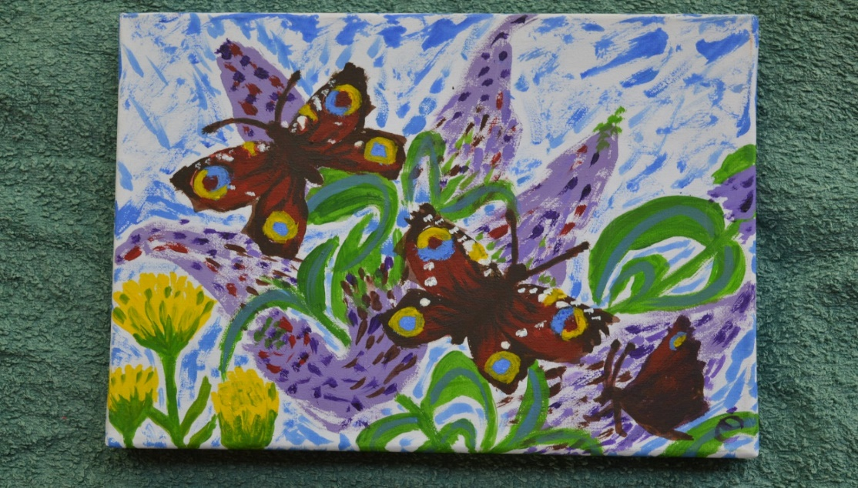
This can give us a sense of well-being we can - ‘take home with us’.

Light refreshments will be available.
Modest prices; donations from sales will be given to church Funds.
FREE ENTRY. In a calm peaceful setting of an old church, next to beautiful walks in the Marshes, we can rest awhile. We can also view unique 14 century wall paintings showing ‘stories’ from the past.

