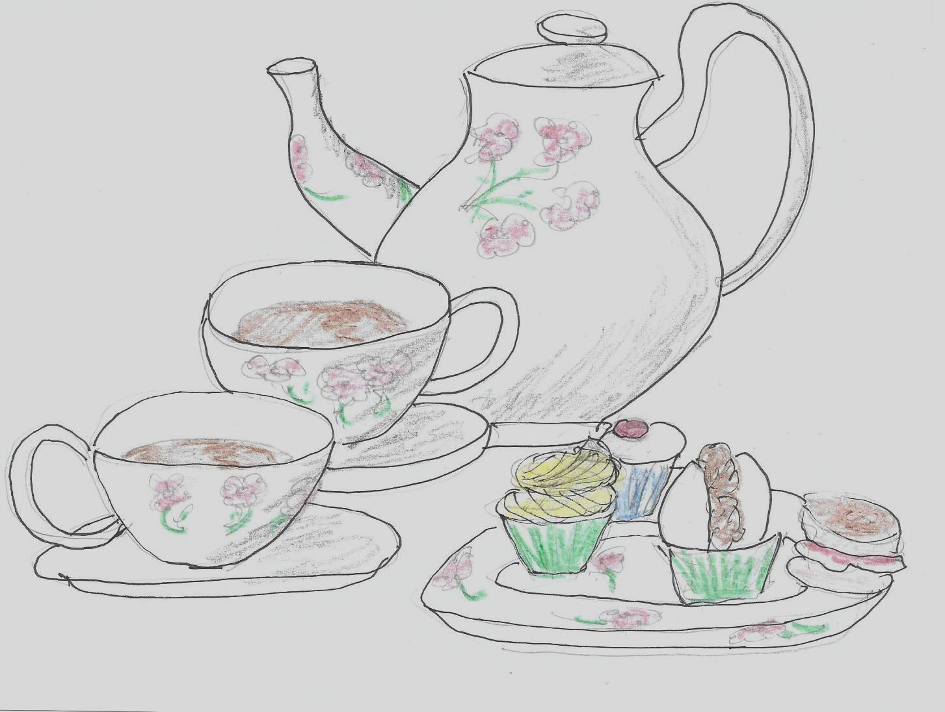
NORFOLK DAY
27th JULY 2018

DELICIOUS
CREAM TEAS
ALL SAINTS CHURCH
FREETHORPE
2:00 – 4:00 pm
Tickets £4 at the door

