**Parish of Beighton with Moulton**

**All Saints Church**

**Re-thatching & Improvements Project**

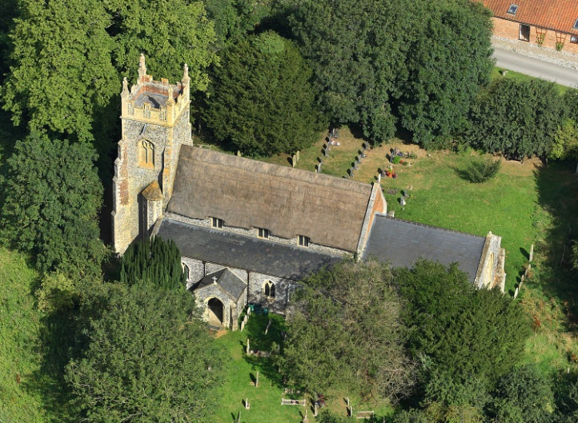

***March 2019 Newsletter***





*Detail view of upper slopes at east end showing beetle holes and*

*diminished and missing sections*

Dear Parishioners

W

e have some fantastic news – the National Lottery Heritage Fund has accepted our second round application and awarded us a grant of £221,000 towards the cost of delivering the All Saints Restoration & Improvements Project! After the extreme disappointment of failing in the previous attempt, we think you’ll agree this news is just so wonderful.

W

hen we wrote to you last, in January 2018, it was at the start of the second attempt to develop the project. We had re-applied to the National Lottery and been given fresh hope when they again granted us a first round pass. With our new architect on board, Domenico D’Alessandro of Nicholas Warns Architect Ltd, things quickly progressed. The large holes that had appeared on the south side of the thatched Nave were successfully patched up to stop any more wind and wet getting in. Whilst the scaffolding was up, the architects took the opportunity to check roof timbers that were exposed and were pleased to find they were surprisingly dry. However, it was revealed that areas of the flint facing around the high-level windows (clerestorey) on the north and south sides were worryingly loose as was a large area on the Chancel east wall.

I

n March and April opening-up inspection days were held and attended by the architects, Historic England, a structural engineer, a wildlife consultant, an historian, an archaeologist, a wall painting conservator and a stained glass expert for the purposes of compiling reports in their respective areas of expertise. At the same time, percolation tests were carried out in parts of the churchyard in relation to the drainage system for the proposed kitchen and toilet. When all the reports had been received the project architect was able to develop plans and specifications over the summer months to form the documentation for the tenders. These were submitted to the Heritage Lottery for scrutiny by the Historic England advisers and happily no queries were raised.

T

his meant we could go to tender and the five interested contractors all returned priced tenders. These ranged from £267,187 to £396,727 - ouch! Bearing in mind this was without fees on top ... After discussions with the architect and quantity surveyor, some of the work was scaled back to get it down to what was felt to be a realistic working budget of £229,500 for the delivery of project. Again plus fees, activities and other costs, bringing the total grant-eligible costs based on the lowest tender to £325,982.

I

n the meantime, statutory permissions were sought from the Environment Agency, Building Control and a Faculty from the Diocesan Chancellor to carry out the work. All have been received satisfactorily.

T

he second round application to the Heritage Lottery Fund was submitted on 14 December for funds to help deliver the project and the waiting began again. The HLF Grants’ Committee was due to consider our bid on 28 March but a phone call was received in early February to say they would be making a decision sooner, at the end of February. On Tuesday 5 March the PCC Treasurer, Kate Ashcroft, received the all-important phone call – we had passed! The Committee had agreed to award us the grant. Allelulia!

Anticipated funding for delivering the project is as follows:

Heritage Lottery Fund second round application - secured 221,000

Estimated VAT reclaim 49,999

Appeal Fund - secured 3,000

Norfolk Churches Trust - secured 7,000

The Garfield Weston Foundation -secured 10,000

The Geoffrey Watling Trust -secured 1,500

National Churches Trust (application in progress) 20,000

Local appeal, donations & other grants 7,483

Norfolk Churches Trust (possible additional grant) 3,000

Volunteer time – *offset against costs* 3,000

**Total £325,982**

S

S

S

S o as you can see, there is still some way to go with the fundraising. Although we are requesting £20,000 from the National Churches Trust and a further £3,000 from the Norfolk Churches Trust, there are no guarantees we will get the full amount requested. Put simply, we need to find £31,083. If all the funding is in place, there is a good chance work can begin in late summer.

E

vents planned for 2019 to generate local funds kicked off with a very successful Ceilidh on 2 March, dancing to The Keel Band. Fifty-plus people attended and it was a fabulous evening which raised just over £500 towards the Appeal Fund.

F

uture dates for your diary are:

**Monday 22 April** Easter Monday -Easter Eggstravaganza

**Saturday 18 May** Car Treasure Hunt

**Saturday 15 June** Fete with Auction and Strawberry Teas

The project team (Tess, Carolyn, Suzanne, Julie, Giles and Kate) very much look forward to meeting you at any or all of the above events but if you are unable to join us, please consider making a donation using the form on the back page. Your support over the last few years has been tremendous. Since starting out on this major project you have helped us raised over £11,000! That is an incredible achievement; the church council and project team can’t thank you enough.

We are so close to restoring and improving All Saints. Please help us to achieve this goal and preserve this beautiful building for the future.

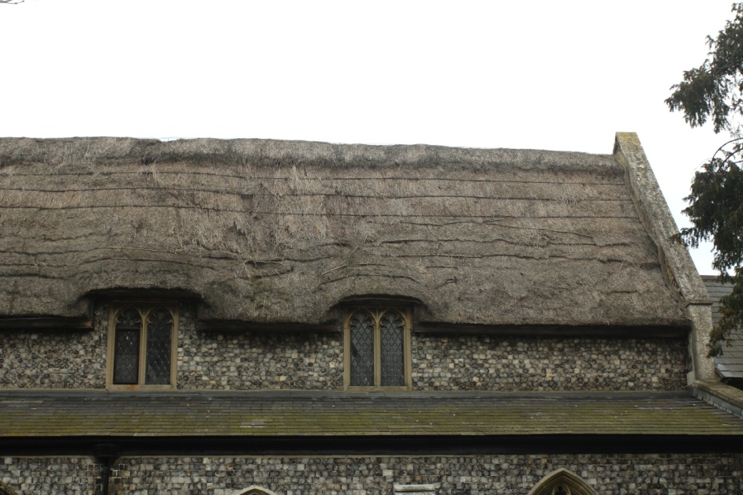

*Nave roof south slope showing dilapidated thatch*